**CHAPTER ONE**

# INTRODUCTION

**1.1 BACKGROUND OF THE PROJECT**

In a country that is faced with serious problem of electricity supply leading to high cost of electricity tariffs, there is a great need for proper management of electrical energy to curtail wastage and maximise the utility of the scarce resources.

With the advent of prepaid meter for electricity tariffs control where a consumer pays for every power consumed, many people have been deterred from the use of public power supply owing to the high bill which could not have been the case if the energy is properly managed.

One of the factors that lead to poor management of electricity is carelessness and the liability of man to forgetting. Most times, due to the myriads of activities flooding human mind and some other times due to the stresses arising from the activities of human mind, human beings tend to forget to switch off the appliances in the room or office after usage.

Another factor that leads to the wastage of electrical energy is a situation whereby the fan or air conditioner (AC) is allowed to be on when they are not necessary. That is, when the room or office is cool enough such that further cooling is not necessary. This not only leads to poor management of electrical energy but also poses health challenge such as pneumonia or catarrh due to excessive cooling of the room.

Also, energy wastage can arise when the lightings are left on when the room or office is properly illuminated by natural light.

There is a need for a smart energy management system that will automatically control the switching ON and OFF of the loads in a room or office such that the loads only consume energy when there are being utilised.

Smart systems incorporate functions of sensing, [actuation](https://en.wikipedia.org/wiki/Actuator), and control in order to describe and analyse a situation, and make decisions based on the available data in a [predictive](https://en.wikipedia.org/wiki/Predictive_analytics) or adaptive manner, thereby performing smart actions. In most cases the “smartness” of the system can be attributed to autonomous operation based on [closed loop control](https://en.wikipedia.org/wiki/Control_theory), [energy efficiency](https://en.wikipedia.org/wiki/Efficient_energy_use), and networking capabilities. [1]

In this project, the system will be able to sense human presence, luminance and the ambient temperature of the room or office under control to determine whether to switch ON or OFF the load(s) at any given time.

More so, there are cases of people barging into an office causing unnecessary distractions. There is a need for a system that can keep tracks of the number of people that entered the office and display it on a screen so that a visitor to the office will know whether to enter or wait to avoid distractions. This feature is incorporated in this project using Liquid crystal display (LCD) as the display screen.

The smart energy management system for homes/offices is an electronic system that controls the switching ON and OFF of the loads under control in a room based on human presence detection, luminance and ambient temperature of the room at any given time.

This system deploys the wonderful features of the Microchip’s PIC16f877A microcontroller which is programmed to perform a given task based on the inputs from the sensors interfaced to it.

**1.2 PROBLEM STATEMENT**

Energy wastage can lead to increased cost of procuring electricity as the bill is strictly based on the amount of energy consumed. This wastage can be attributed to human carelessness and inefficiency.

This project will proffer solution to this problem by automatically controlling the switching ON and OFF of the loads under control so that the load(s) will only be turned on when it is necessary.

**1.3 AIM AND OBJECTIVES**

The aim of this project is to design and implement a smart energy management system that will help consumers of electrical energy to properly utilise the energy they paid for without unnecessary wastage.

To achieve the aim stated above, the following objectives are adopted:

* 1. Design 5V DC power supply unit required to power the circuit components.
  2. Design a temperature detector circuit to monitor the ambient temperature of the room/office.
  3. Design a motion detector circuit that will detect human presence in the room/office.
  4. Design a darkness detecting circuit which determines whether turning on light is necessary or not.
  5. Design an actuation circuit that will perform the switching ON and OFF of the loads.
  6. Design a display using liquid crystal display (LCD) which is used to display the ambient temperature and the number of persons in the office.
  7. Interface the above circuits to a PIC16F877A microcontroller which serves as the central processing unit of the system by processing the inputs from the detector circuits and giving the outputs through the LCD and the actuation circuit.
  8. Develop a software program in embedded C language that will control the activities of the microcontroller.
  9. Construct a prototype to validate the functionality of the project.

**1.4 SCOPE OF THE PROJECT**

This project is limited to the development of a system which detects when a person enters or leaves a room or office, monitors the temperature of the room or office and detects the degree of illumination of the room or office. When a person enters the room/office; the system checks if the natural illumination of the room/office is insufficient before the light is turned on. It also checks if the temperature of the room/office is such that cooling is required before the fan is turned on. The number of person in the room/office recorded by the system and the ambient temperature at any given time is displayed on the LCD.

When all the persons that entered the room/office have left, the system automatically switches off the loads that were turned on.

This is achieved through a microcontroller (PIC16F877A) controlled by software program written in C language which serves as the central processing unit of the entire system.

**1.5 SIGNIFICANCE OF THE STUDY**

This project presents a system which provides solution to the problem of energy wastage owing to carelessness and human inefficiency which leads to poor utilization of the electricity paid for.

More so, by displaying the number of persons in the room/office informs visitors to the office whether to enter or wait thereby reducing unnecessary distractions to the office.

**CHAPTER TWO**

**LITERATURE REVIEW**

Smart systems incorporate functions of sensing, [actuation](https://en.wikipedia.org/wiki/Actuator), and control in order to describe and analyse a situation, and make decisions based on the available data in a [predictive](https://en.wikipedia.org/wiki/Predictive_analytics) or adaptive manner, thereby performing smart actions. In most cases the “smartness” of the system can be attributed to autonomous operation based on [closed loop control](https://en.wikipedia.org/wiki/Control_theory), [energy efficiency](https://en.wikipedia.org/wiki/Efficient_energy_use), and networking capabilities [1].

Smart homes hold the potential for increasingenergy efficiency, decreasing costs of energy use, decreasing thecarbon footprint by including renewable resources, and transforming the role of the occupant[2].

Consumer electronics, office equipment and other plug loads consume 15 to 20 per cent of total residential and commercial electricity while not in primary mode. Much of this energy is consumed when these devices operate in low-power modes but are not actually in use. One way to reduce this unnecessary electricity consumption is to use a smart energy management system.

**2.1 OVERVIEW OF THE PROJECT**

**2.1.1 MOTION DETECTING SYSTEM**

A motion detector is a device that detects moving objects, particularly people. A motion detector is often integrated as a component of a system that automatically performs a task or alerts a user of motion in an area. Motion detectors form a vital component of security, [automated lighting control](https://en.wikipedia.org/wiki/Lighting_control_system), home control, energy efficiency, and other useful systems [3].

**2.1.2 MOTION DETECTOR TECHOLOGY**

There are several motion detection technologies wide in use.

* **Passive infrared (PIR)**

Passive infrared sensors are sensitive to a person's skin temperature through emitted [black body radiation](https://en.wikipedia.org/wiki/Black_body_radiation) at [mid-infrared](https://en.wikipedia.org/wiki/Infrared#ISO_20473_scheme) wavelengths, in contrast to background objects at room temperature. No energy is emitted from the sensor, thus the name "passive infrared" (PIR). This distinguishes it from the [electric eye](https://en.wikipedia.org/wiki/Electric_eye) for instance (not usually considered a "motion detector"), in which the crossing of a person or vehicle interrupts a visible or infrared beam [3].

* **Microwave**

These detect motion through the principle of Doppler [radar](https://en.wikipedia.org/wiki/Radar), and are similar to a [radar speed gun](https://en.wikipedia.org/wiki/Radar_speed_gun). A [continuous wave](https://en.wikipedia.org/wiki/Continuous_wave) of [microwave](https://en.wikipedia.org/wiki/Microwave) radiation is emitted, and phase shifts in the reflected microwaves due to motion of an object toward (or away from) the receiver result in a [heterodyne](https://en.wikipedia.org/wiki/Heterodyne) signal at low [audio frequencies](https://en.wikipedia.org/wiki/Audio_frequencies) [3].

* **Ultrasonic**

An ultrasonic wave (sound at a frequency higher than a human ear can hear) is emitted and reflections from nearby objects are received.Exactly as in Doppler radar, heterodyne detection of the received field indicates motion. The detected [Doppler shift](https://en.wikipedia.org/wiki/Doppler_shift) is also at low audio frequencies (for walking speeds) since the ultrasonic [wavelength](https://en.wikipedia.org/wiki/Wavelength) of around a centimetre is similar to the wavelengths used in microwave motion detectors. One potential drawback of ultrasonic sensors is that the sensor can be sensitive to motion in areas where coverage isn't desired, for instance, due to reflections of sound waves around corners. Such extended coverage may be desirable for lighting control, where the point is detection of any occupancy in an area. But for opening an automatic door, for example, one would prefer a sensor selective to traffic in the path toward the door [3].

* **Tomographic motion detector**

Tomographic motion detection systems sense disturbances to radio waves as they pass from node to node of a mesh network. They have the ability to detect over complete areas because they can sense through walls and other obstructions [3].

* **Video camera software**

With the proliferation of inexpensive [digital cameras](https://en.wikipedia.org/wiki/Digital_camera) capable of shooting video, it is possible to use the output of such a camera to detect motion in its field of view using [software](https://en.wikipedia.org/wiki/Software). This solution is particularly attractive when the intention was to record video triggered by motion detection, as no hardware beyond the camera and computer is required. Since the observed field may be normally illuminated, this may be considered another *passive* technology. However it can also be used in conjunction with [near-infrared](https://en.wikipedia.org/wiki/Near-infrared) illumination to detect motion in the "dark" (that is, with the illumination at a wavelength not detected by the human eye). [3]

However, for the purpose of this study only passive infrared (PIR) technology will be considered since the target is to detect human presence.

**2.1.3 PIR SENSOR OPERATING PRINCIPLE**

An individual PIR sensor detects changes in the amount of infrared radiation impinging upon it, which varies depending on the temperature and surface characteristics of the objects in front of the sensor. When an object, such as a [human](https://en.wikipedia.org/wiki/Human), passes in front of the background, such as a [wall](https://en.wikipedia.org/wiki/Wall), the temperature at that point in the sensor's field of view will rise from [room temperature](https://en.wikipedia.org/wiki/Room_temperature) to [bodytemperature](https://en.wikipedia.org/wiki/Body_temperature), and then back again. The sensor converts the resulting change in the incoming infrared radiation into a change in the output voltage, and this triggers the detection. Objects of similar temperature but different surface characteristics may also have a different infrared emission pattern, and thus moving them with respect to the background may trigger the detector as well [4].

**2.1.3 DARKNESS ACTIVATED CIRCUIT**

In a bid to effectively conserve energy, the control of when light is turned or off when necessary is paramount importance. A common application of this concept can be found in street lighting systems.

Street lights are designed to switch on automatically when it is dark and switch off when there is light so as to save energy.

A common component used is called a light dependent resistor (LDR). It is a resistor with resistance that changes according to the amount of light falling on it. When the LDR is in the dark, its resistance is very large, typically over a million ohms. When it is under bright light, its resistance is only about a few thousand ohms. A circuit that makes use of this change in resistance at different light conditions is able to switch on and off the street and road lights during night and day time respectively [5].

However, for domestic application as in the case of this study, this circuit can be adjusted to respond to lower intensity of darkness since the room or office might need light even in the day depending on the weather at a particular time.

**2.1.4 AMBIENT TEMPERATURE SENSING CIRCUIT**

Another step to further save energy is to control when the fan or air conditioner (AC) is turned on so that when the room under control is cool enough the fan or AC will be turned off. Although this feature is already incorporated in the recent air conditioners, it is still lacking in fan. Since most people make use of fan than AC for cooling of rooms or offices it becomes necessary to design a system that will compensate for this shortcoming.

There several sensors that can be used to acquire ambient temperature but for this study LM35 temperature sensor will be used. The choice of LM35 amongst other sensors is facilitated by its features such as accuracy, high sensitivity, low cost, fast response and availability among others. Another interesting feature of the LM35 is the range which is -55 to +150 degree Celsius [6]; this range is suitable for domestic use.

**2.2 REVIEW OF RELATED LITERATURES**

ABHIJEET V. JOSHI et al [7]attempted to minimize energy wastage by automatically controlling when the fan in a room is turned ON and at what speed depending on the ambient temperature of the room. The interesting feature of this work is the system’s ability to adjust the speed of the fan as the temperature changes. However, it failed to care of whether a person is in the room or not. A better approach should be that the system should be able to detect human presence in the room before checking whether to turn the fan ON and the system should also be able to turn OFF the fan when nobody is in the room. Another shortcoming of this work [7] is that the lightings in the room were not taken into account which is another crucial factor to energy consumption.

Instructible.com [8] in a project titled “Smart home energy monitoring and management systemdeveloped a system that will be capable of keeping the track of each and every appliance in the home. It provides the user the information about the appliance energy consumption parameters. Along with this, the energy consumption parameters of each individual appliance will be sent to gateway where an intelligent algorithm will be running to manage all the appliances as per user requirements. The user can monitor the energy parameters of each individual load using an android smartphone which will also work as a data setter to set various user programmable parameters like high/low cut-off voltage, etc.The focus of this work is on monitoring the behavior of the individual loads in order to decide which load consumes more energy than the other.

Although this work succeeded in managing energy in a dynamic way, it has some limitations in its application. It can only be applied in the developed countries where Smart Metering system is used. The need for an android application interface increased the complexity and the cost of the system.

XiangyangLi ,Weiqiang Zhang ,Hujing [9] proposed a system in which Control Center uses 32-bit embedded RISC processor based ARM11 architecture. ZigBee wireless module is embedded in control centre and various appliances, in order to achieve wireless connectivity appliances and intelligent control of appliances. Control centre is the core component of intelligent home appliance system, it is actually a full-featured embedded systems. Hardware design uses a powerful ARM11 chip and other functional modules. Touch screen is man-machine interface; user can control home appliances through it. ZigBee wireless module implements the communication of home device.

Dae-man Han and Jae-Hyun Lim[10] designs smart home device descriptions and standard practices for demand response and load management “Smart Energy”applications needed in a smart energy based residential or light commercial environment. In short, lighting control systems deliver the correct amount of light, where you want it, when you want it. Lights can automatically turn on, off or dim at set times or under set conditions, plus users can have control over their own lighting levels to provide optimal working conditions. Lighting control helps to reduce costs and conserve energy byturning off (or dimming) lights when they are not required

Hong, Byoungjoo Lee, and Sehyun Park [11] utilizes multi sensors and wireless communication technology in order to control an LED light according to the user’s state and the surroundings.The proposed LED lighting system can autonomously adjust the minimum light intensity value to enhance both energy efficiency and user satisfaction.

Wang Huiyong, Wang Jingyang, Huang Min [12] presented a system whose architecture includes five main blocks - the home server, the WSN system, smart devices, network of cameras, and mobile service robots. The home server is the center of information and the control centre of the whole smart home system. It provides means to store information, monitor the devices, and send particular tasks of the user and then prepare plans in a centralized way.

Kirtika .K. Lunawa, Prof. U.M. Gokhale[13] designed and implemented a home appliance control and energy management system using PIR sensors. The PIR sensors were used to detect the presence of people in the room so that the loads are automatically turned off when nobody is in the room and the per day energy consumption is displayed on an LCD. The work also made use of LDR to maintain the light intensity of the room. The work did not only focus on saving energy; it incorporated also smoke detector to alert the user in times of fire emergency via GSM module. However the temperature of the room is not taken into account as a determining factor to turning on or off fan which is one of the major loads that consumes energy and a considerable amount of energy can be wasted if it is not properly managed.

**2.3 SUMMARY OF REVIEWS**

The reviews were carried out to shed light on some of the related works that have been carried out by other researchers towards the reduction of energy wastage.

However, this work tends to address some of the shortcomings that were observed in the reviewed works. For instance, the work in [9] used most of the approached use in this study but failed to take into account the temperature of the room as a key to turning on or off the fan when someone is in the room. This has been taken into account in this work by using LM35 temperature sensor to obtain the temperature of the room and based on it determine if the room requires the fan to be turned on or off.

Moreover, this work has a special feature for office use especially in an academic environment where students walk in and out of the office most frequently. Barging into an office can be annoying and most times it can cause unnecessary disturbance. This work proffers solution to this problem by keeping the record of the number of people in the office at any given time and displaying it on an LCD. The ambient temperature of the room is also displayed on the LCD.

**CHAPTER THREE**

**METHODOLOGY AND SYSTEM ANALYSIS**

**3.1 METHODOLOGY**

Methodology is the systematic, theoretical analysis of the methods applied to a field of study. It comprises the theoretical analysis of the body of methods and principles associated with a branch of knowledge [14].

In this project, incremental prototyping methodology was used. The final product is built on separate prototypes. At the end, the separate prototypes are merged in an overall design.

**3.1.1 Outline of the process**

Subsystem

Identification

Design/ Development of subsystem units

Simulation of subsystem units

Subsystem unit integration

Testing and system analysis

Hardware implementation

**Fig 3.1 block Diagram of process**

* **Subsystems identification**

The required subsystems for successful implementation of the project were identified.

The various interconnections of the various subsystems are illustrated with the block diagram as shown below:

Control Unit

Power supply unit

Temperature sensing unit

Motion sensing unit

Display unit

Switching unit

Loads

Motion sensing unit

**Fig 3.2 Block Diagram of a Smart Energy Management System for Homes/Offices**

* **Design/Development of subsystems**

Each of the subsystems above was designed using the computer aided design (CAD) tools described later in this chapter and simulated for proper functionality. The various circuit diagrams of the subsystems are given below:

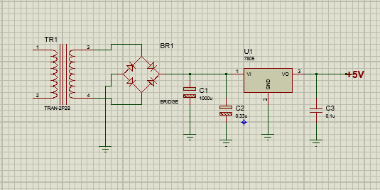

**Fig 3.3 The power supply unit**



**Fig 3.4 Display unit**

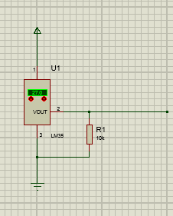

Fig 3.5 Temperature Sensing unit

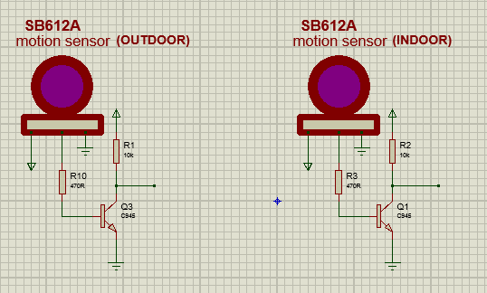

Fig 3.6 Motion sensing unit

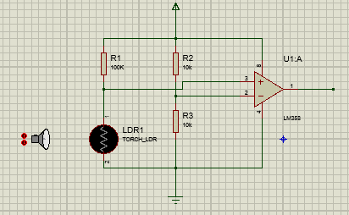

Fig 3.6 Darkness sensing unit

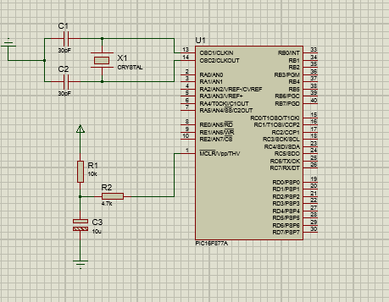

Fig 3.7 Control unit (PIC16F877A microcontroller)

* **Subsystem units integration**

Having simulated the individual subsystem units and upon proper functionality, the various units were integrated to validate the design as show below:

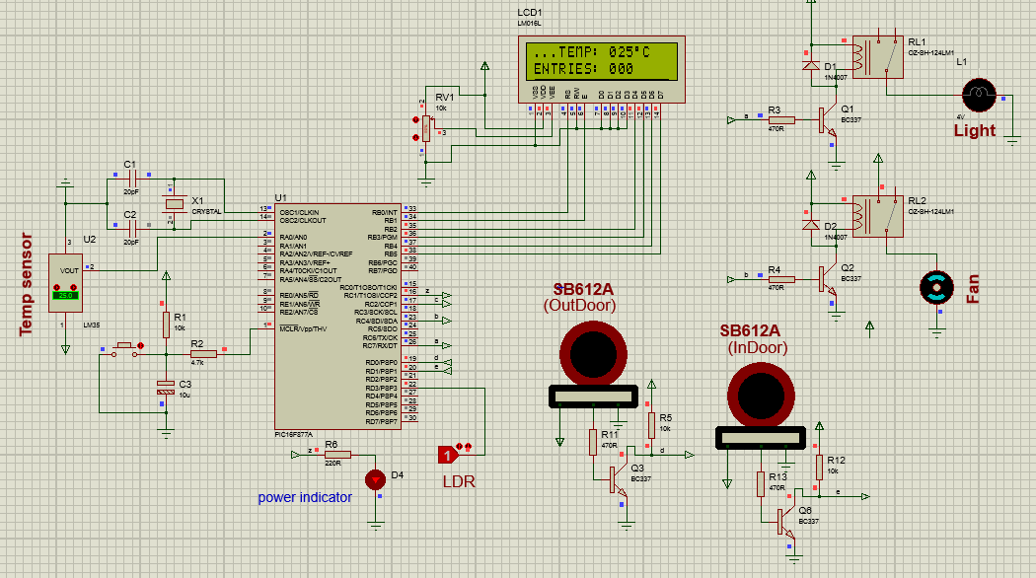

Fig 3.7Complete circuit Diagram of the system

* **Testing and system analysis**

The complete system was tested, and results obtained showed that it works according to specifications. Hence the design was implemented using hardware.

**3.1.2 Tools used in the project**

The tools used to facilitate the design, simulation and implementation of this project work include

* Proteus 8.0
* MikroC compiler
* PicKit 2 programmer

**3.1.2.1 Proteus 8.0**

This is a CAD tool for microprocessor simulation, schematic capture, and printed circuit board (PBC) design. It is developed by Labcenter Electronics [15].

Its components include:

* **ISIS Schematic Capture**: a tool for entering designs.
* **ARES PBC Layout**: PBC design system with automatic component placer, rip-up and retry auto-router and interactive design rule checking.
* **VSM**: Virtual system modelling lets co-simulate embedded software for popular microcontrollers, alongside hardware design.
* **System Benefits**: integrated package with common user interface and fully context sensitive help.

**3.1.2.2 MikroC Compiler**

mikroC is a full-featuredANSI C compiler for PIC devices from Microchip®. It is the best solution for developing code for PIC devices. It features intuitive IDE, powerful compiler with advanced optimizations*,* lots of hardware and software libraries, and additional tools that will help in the development of embedded system projects [16].

**3.1.2.3 PICKit 2 Programmer**

The PICkit™ 2 Development Programmer/Debugger (PG164120) is a low-cost development tool with an easy to use interface for programming and debugging Microchip’s Flash families of microcontrollers [17].This was used to burn the program into the microcontroller.

**3.2 SYSTEM ANALYSIS AND DESIGN**

**3.2.1 Structural Analysis**

This project work involves the design and construction of a smart energy management system. This system ensures that the electrical energy paid for is properly utilised without wastage; the system achieves this by ensuring that the light is turned ON only when a person(s) is in the room and the room is not properly illuminated by natural light, the fan is also turned ON only when a person(s) is in the room and the ambient temperature is such that cooling is required. It also keeps the records of the number of people in the room or office at a particular time which makes it even more useful in an academic environment where students are fond of barging into office causing unnecessary distractions; this system addresses this problem by displaying the number of person in the office on an LCD so that the visitor to the office will make the right decision of entering or waiting.

In order to achieve these functionalities, the design is made up of four broad blocks:

* The power supply unit
* The control unit
* The input unit
* The output unit

POWER SUPPLY UNIT

CONTROL UNIT

INPUT UNIT

OUTPUT UNIT

**Fig 3.8 Block diagram of the simplified system structure**

**3.2.1.1 THE POWER SUPPLY UNIT**

Every electronic circuit requires a direct current (DC) power supply to function as virtually all electronic components are operated at DC level. Conventionally, power is supplied in alternating current (AC) form from the public power supply hence the need for a conversion circuit that will convert the AC source to DC level. A transformer is used to step down the AC source voltage from 230V AC to 12V AC. The 12V AC is passed through a bridge rectifier which converts it to a unidirectional pulsating 12V DC output. The output voltage after rectification is still pulsating because of the presence of ripples. The ripple is filtered out through a filter capacitor.

The microcontroller and most of the peripherals such as the LCD used in this project requires a stable 5V power supply to function, hence LM7805 voltage regulator is used to further convert and regulate the 12V DC to a stable 5V DC .

AC source

Regulator

Transformer

Rectifier

Filter

**Fig 3.9 Block diagram of the regulated power supply**

**3.2.1.2 THE CONTROL UNIT**

The control unit consists of a microcontroller unit. A microcontroller is a small computer on a single chip in that it contains all the component units of a computer such as the central processing unit (CPU), the memory unit- Random Access Memory (RAM) and Read Only Memory (ROM), input/output unit.

The microcontroller used in this project is PIC16F877A from Microchip Incorporated. The special features of this microcontroller that informed its choice in this project include the following:

* It has current sinking and sourcing capability
* It has reduced instruction set computer (RISC) architecture
* It has built-in analog-to-digital converter (ADC).
* It has fast response of four (4) clock pulse per instruction cycle.

The detailed features of the PIC16F877Amicrocontroller are as follows:

High-Performance RISC CPU:

* Only 35 single-word instructions to learn.
* All single-cycle instructions except for programbranches, which are two-cycle.
* Operating speed: DC – 20 MHz clock DC – 200 ns instruction cycle
* Up to 8K x 14 words of Flash Program Memory, Up to 368 x 8 bytes of Data Memory Up to 256 x 8 bytes of EEPROM Data Memory.

Analog Features:

* 10-bit, up to 8-channel Analog-to-DigitalConverter (A/D)
* Brown-out Reset (BOR)
* Analog Comparator module with:

- Two analog comparators

- Programmable on-chip voltage reference(VREF) module

- Programmable input multiplexingfrom deviceinputs and internal voltage reference

- Comparator outputs are externally accessible.

Peripheral Features:

* Timer0: 8-bit timer/counter with 8-bit prescaler
* Timer1: 16-bit timer/counter with prescaler, can be incremented during Sleep via external crystal/clock
* Timer2: 8-bit timer/counter with 8-bit period register, prescaler and postscaler.
* Two Capture, Compare, PWM modules

- Capture is 16-bit, maximum resolution is 12.5ns

- Compare is 16-bit, maximum resolution is 200ns

- PWM maximum resolution is 10-bit

* Synchronous Serial Port (SSP) with SPI (Master mode) and I2C™ (Master/Slave)
* Universal Synchronous Asynchronous Receiver Transmitter (USART/SCI) with 9-bit address detection
* Parallel Slave Port (PSP) – 8 bits wide with external RD, WR and CS controls (40/44-pin only)
* Brown-out detection circuitry for Brown-out Reset (BOR).

Special Microcontroller Features:

* 100,000 erase/write cycle Enhanced Flashprogram memory typical
* 1,000,000 erase/write cycle Data EEPROM memory typical
* Data EEPROM Retention > 40 years
* Self-reprogrammable under software control
* In-Circuit Serial Programming™ (ICSP™) via two pins
* Single-supply 5V In-Circuit Serial Programming
* Watchdog Timer (WDT) with its own on-chip RC oscillator for reliable operation
* Programmable code protection
* Power saving Sleep mode
* Selectable oscillator options
* In-Circuit Debug (ICD) via two pins
* **PIN DESCRIPTION OF PIC16F877A**

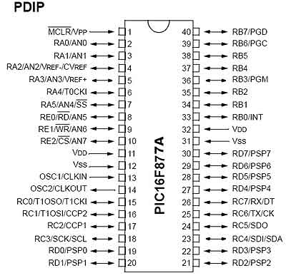

**Fig 3.10 Pin Diagram of PIC16F877A**

The pins of PIC16F877A are described as follows:

**PIN 1: MCLR**

The first pin is the master clear pin of PIC16F877A. It resets the microcontroller and is active low, meaning that it should constantly be given a voltage of 5V and if 0 V are given then the controller is reset. Resetting the controller will bring it back to the first line of the program that has been burned into the microcontroller.

**PIN 2: RA0/AN0**

PORTA consists of 6 pins, from pin 2 to pin 7, all of these are bidirectional input/output pins. Pin 2 is the first pin of this port. This pin can also be used as an analog pin AN0. It is built in [analog to digital converter](http://microcontrollerslab.com/analog-to-digital-adc-converter-working/).

**PIN 3: RA1/AN1**

This can be the analog input 1.

**PIN 4: RA2/AN2/Vref-**

It can also act as the analog input2. Or negative analog reference voltage can be given to it.

**PIN 5: RA3/AN3/Vref+**

It can act as the analog input 3. Or can act as the analog positive reference voltage.

**PIN 6: RA0/T0CKI**

To timer0 this pin can act as the clock input pin, the type of output is open drain.

**PIN 7: RA5/SS/AN4**

This can be the analog input 4. There is synchronous serial port in the controller also and this pin can be used as the slave select for that port.

**PIN 8: RE0/RD/AN5**

PORTE starts from pin 8 to pin 10 and this is also a bidirectional input output port. It can be the analog input 5 or for parallel slave port it can act as a ‘read control’ pin which will be active low.

**PIN 9: RE1/WR/AN6**

It can be the analog input 6. And for the parallel slave port it can act as the ‘write control’ which will be active low.

**PIN 10: RE2/CS/A7**

It can be the analog input 7, or for the parallel slave port it can act as the ‘control select’ which will also be active low just like read and write control pins.

**PIN 11 and 32: VDD**

These two pins are the positive supply for the input/output and logic pins. Both of them should be connected to 5V.

**PIN 12 and 31: VSS**

These pins are the ground reference for input/output and logic pins. They should be grounded.

**PIN 13: OSC1/CLKIN**

This is the oscillator input or the external clock input pin.

**PIN 14: OSC2/CLKOUT**

This is the oscillator output pin. A crystal resonator is connected between pin 13 and 14 to provide external clock to the microcontroller.

**PIN 15: RC0/T1OCO/T1CKI**

PORTC consists of 8 pins. It is also a bidirectional input output port. Of them, pin 15 is the first. It can be the clock input of timer 1 or the oscillator output of timer 2.

**PIN 16: RC1/T1OSI/CCP2**

It can be the oscillator input of timer 1 or the capture 2 input/compare 2 output/ PWM 2 output.

**PIN 17: RC2/CCP1**

It can be the capture 1 input/ compare 1 output/ PWM 1 output.

**PIN 18: RC3/SCK/SCL**

It can be the output for SPI or I2C modes and can be the input/output for synchronous serial clock.

**PIN 23: RC4/SDI/SDA**

It can be the SPI data in pin. Or in I2C mode it can be data input/output pin.

**PIN 24: RC5/SDO**

It can be the data out of SPI in the SPI mode.

**PIN 25: RC6/TX/CK**

It can be the synchronous clock or USART Asynchronous transmit pin.

**PIN 26: RC7/RX/DT**

It can be the synchronous data pin or the USART receive pin.

**PIN 19, 20, 21, 22,27,28,29,and 30:**

All of these pins belong to PORTD which is again a bidirectional input and output port. When the microprocessor bus is to be interfaced, it can act as the parallel slave port.

**PIN 33-40: PORT B**

All these pins belong to PORTB. Out of which RB0 can be used as the external interrupt pin and RB6 and RB7 can be used as in-circuit debugger pins [18].

**3.2.1.2 THE INPUT UNIT**

The input unit comprises the temperature sensing unit, the motion sensing unit, and the darkness sensing unit.

* **The temperature sensing unit**

It consists of Temperature sensor LM35. This sensor senses the temperature of room or office. It is basically a transducer, which converts the sensed temperature value in its equivalent voltage. LM35 gives 10mV for every 1 degree rise in temperature [6]. This voltage is in analog form and as such it cannot be fed directly to the microcontroller section. The output of the LM35 is connected to pin **RA1/AN1which is one of the eight ADC channel of the PIC16F877A.**

**Based on the temperature reading obtained, the fan can be turned ON or OFF to ensure that energy is not wasted.**

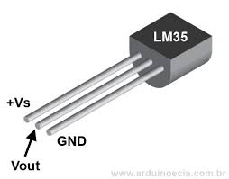

**Fig 3.11 LM35 temperature sensor**

* **The motion sensing unit**

It consists of SB612A passive infrared (PIR) sensors. SB612A is a pyro- electric sensor module which developed for human body detection. An integrated PIR sensor combined with a Fresnel lens which is mounted on a compact PCB, and limited components to form the module [19]. The output of the sensor when it senses is 3.3V DC [19]. In this project, two of this sensor are used in order to detect human presence and as well as differentiating between entry and exit from the room. To achieve this, one of the sensors is mounted outside the door post (outer-sensor) and the other is mounted inside the door post (inner-sensor). If the outer-sensor senses before the inner-sensor, an entry is recorded and if the reverse is the case an exit is recorded. The control program is such that whenever the number of entry recorded is equal to zero, the microcontroller automatically switches OFF all the loads that are turned ON.

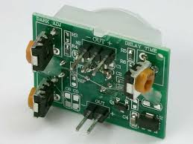

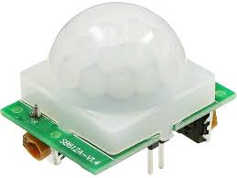

**Fig 3.12 SB612A PIR Sensor Module**

* **The Darkness sensing unit**

This unit consists of a light dependent resistor (LDR). LDR is a type of resistor whose resistance varies with variation in light intensity. The resistance decreases with increase in light intensity and vice versa. In this project, the LDR is used together with LM358 comparator to monitor the light intensity of the room so that the light is turned only when the room is dim or poorly illuminated by natural light. The inverting input of the LM358 is fixed at a certain voltage level while the LDR is connected to the non-inverting input. When darkness increases the resistance of the LDR increases until the fixed voltage at the inverting input is exceeded. The output of the LM358 goes HIGH and the microcontroller is triggered to switch on the light if human presence is detected in the room.

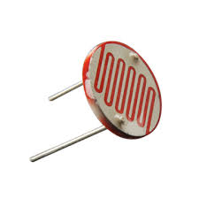

|  |
| --- |
|  |

**Fig 3.13 Light Dependent Resistor**

**3.2.1.2 THE OUTPUT UNIT**

The output unit comprises the display unit and the switching unit.

* **The Display unit**

In recent years, the LCD (see fig 3.4) is finding widespread use in replacing LED. This is due to the following reasons:

* The declining prices of LCDs.
* The ability to display numbers, character, and graphics.
* Ease of programming for characters and graphics.

The function of each LCD pin is given in the table below:

**Table 4.0: LCD pin description**

|  |  |  |
| --- | --- | --- |
| **Pin** | **Symbol** | **Description** |
| 1  2  3  4  5  6  7  8  9  10  11  12  13  14 | VSS  VCC  VEE  RS  R/W  E  DB0  DB0  DB0  DB0  DB0  DB0  DB0  DB0 | Ground  +5Vpower Supply  Power supply to control contrast  RS = 0, To select command register. RS = 1, To select data register.  Rw= 0, for write , Rw = 1, for read  Enable  Data bus line 0 (LSB)  Data bus line 1  Data bus line 2  Data bus line 3  Data bus line 4  Data bus line 5  Data bus line 6  Data bus line 7 (MSB) |

* **VCC, VSS AND VEE**

The VCC and VSS provide +5V and ground respectively, while VEE is used to control LCD contrast.

* **RS: Register Select**

There are two (2) very important registers inside the LCD. The RS pin is used for their selection as follows. If RS = 0, the instruction command code register is selected, allowing the user to send a command such as clear display, cursor at home, etc. if RS = 1, the data register is selected, allowing the user to send data to be display on the LCD.

* **R/W Read/write**

R/W input allows the user to write information to the LCD or read information from it. R/W = 1, when reading, R/W = 0, when writing.

* **Enable**

The enable is used by the LCD to latch information presented to its data pins. When data is supplied to the data pins, a HIGH-to-LOW pulse must be supplied to this pin in order for the LCD to latch in the data present at the data pins. This pulse must be a minimum of 450ns wide.

* **The switching unit**

The major component of this unit is the relay. Relays are electromechanical switch which is used an isolator to isolate two different voltage sources such as DC and AC voltage. A relayis an[electrically](https://en.wikipedia.org/wiki/Electric) operated [switch](https://en.wikipedia.org/wiki/Switch). Many relays use an [electromagnet](https://en.wikipedia.org/wiki/Electromagnet)to mechanically operate a switch, but other operating principles are also used, such as [solid-state relays](https://en.wikipedia.org/wiki/Solid-state_relay). Relays are used where it is necessary to control a circuit by a low-power signal (with complete electrical isolation between control and controlled circuits), or where several circuits must be controlled by one signal [20]. The loads controlled in this project are AC powered while the control unit is powered by DC voltage hence the need for an isolator.

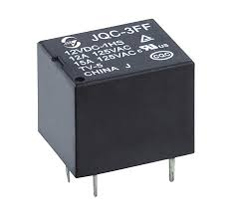

**Fig 3.14 12V DC Relay**

**3.2.2 Design Analysis/ Design Calculation**

**3.2.2.1 Power Supply Design**



* **Transformer (TR1)**

The design of transformer itself is beyond the scope of this work. The transformer (TR1) used has the following specifications which were used in the subsequent design:

Output Voltage: 12V X 2 AC

Current rating: 500mA

* **Filter Capacitor C1**

From coulomb’s law

Q = CVr

Vr  = the ripple voltage

Vr  = peak voltage – (forward voltage drop by 2 diodes + minimum input voltage to LM7805)

But Q = I*t

I = current rating of transformer = 500mA

t = 1/2f ; for full-wave rectification

f = frequency of the AC source voltage = 50Hz

Thus:

$$C= \frac{I}{2fV_{r}}$$

Vr = (12√2) – (0.7x2 + 7)

= 8.57V

* $C=\frac{500x{10}^{-3}}{2x50x8.57}$ =583uF

Based on the calculation above, a filter capacitor of rating 1000uF/25V was used in this work.

* **Filter capacitors C2 and C3**

From the datasheet of LM7805 voltage regulator, the rating of C2 and C3 are recommended as 0.33uF and 0.1uF respectively to further filter and remove noise from the output voltage.

**3.2.2.2 Microcontroller section**

* **Pin 1configuration**



* **R1, R2 and C4**

From the datasheet of PIC16F877A [21], the following values are recommended for R1, R2 and C4

R1 < 40k

R2 >1k

C4 = 10uF

Therefore, for this design R1, R2 were chosen to be 10k and 4.7k respectively.

* **Oscillator Circuit**



PIC16F877A requires external clock signal to function properly. This is achieved with a crystal oscillator. The speed of operation of the microcontroller depends on the frequency of the crystal oscillator. The frequency of the crystal oscillator used in this work is 12MHz and from the datasheet [21], the range of the capacitors C5 and C6 is 20-30pF. Thus 30pF was chosen for C5 and C6.

**3.2.2.3 Motion Sensing Unit**

* **The Out-door Sensor**



From Kirchhoff’s voltage law:

$$Vo-I_{B}R_{B }-V_{BE}=0$$

Where

Vo = the output voltage from the motion sensor

Vo = 3.3V

IB = the base current of the transistor Q1

From the datasheet of BC337 (Q1):

IB = 10mA at saturation and VBE = 0.7V

Thus:

RB= = 260

Therefore, in this work, the value of R3 is chosen to be 470 Ohms to ensure that the transistor is not operated at its maximum point.

* **The In-door sensor**



The circuit for both Out-door sensor and In-door sensor are the same. It therefore follows that the value of R6 is 470Ohms.

* **The pull-up Resistors R4 and R6**

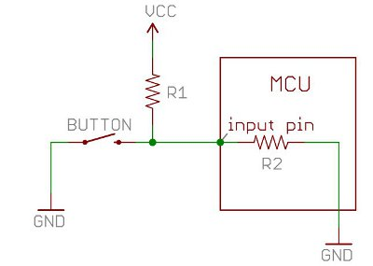

R4

Rin

The input impedance of the microcontroller, Rin ranges from 100k to 1M ohms. If the pin is used as input pin, the input impedance will be high and the pin will be floating such that the state of the pin cannot be predicted before external signal is applied. The pull-up resistor establishes a voltage divider with the input impedance.

Thus;

VRin =

Vcc = 5v

Assuming R4 = 10k

VRin = = 4.5V

Therefore, with pull-up resistor of 10kilohm, the input pin will be constantly held HIGH before the external signal is applied. Based on this calculation, the value of pull-up resistors used in this work is 10kilohms each.

**3.2.2.4 The Switching Unit**



* **Biasing Resistor R7**

From Kirchhoff’s voltage law:

$$Vo-I_{B}R_{B }-V_{BE}=0$$

Where

Vo = the output voltage from the microcontroller pin

Vo = 5V

IB = the base current of the transistor Q3

From the datasheet of BC337 (Q3):

IB = 10mA at saturation and VBE = 0.7V

Thus:

RB= = 430 ohms

Therefore, the value of the biasing resistors for the switching transistors is chosen to be 470 ohms which is the available standard value.

**3.2.3 System Program Flowchart**

No

Check Temperature

Yes

Yes

Initialize System

Read Temperature

Check for Entry & Update Entry

Display Temperature

Display Entry

Is Entry >= 1?

Turn OFF Light and Fan

Check Illumination

Is the room lit?

Turn ON Light

Turn OFF light

Is Temp >= 25?

Turn OFF FAN

Turn ON Fan

No

No

Yes

Check for Exit

Is there Exit?

Decrement Entry

Yes

No

Fig 3.14 System Program Flowchart

**CHAPTER FOUR**

**SYSTEM IMPLEMENTATION/RESULT ANALYSIS**

**4.1 Functional Simulation**

The design is firstly validated using Proteus ISIS software. The schematic of the circuit was captured and then synthesized with the control program. The result obtained was in line with the conceived physical system.

**4.2 Construction of the system**

Construction of the project was carried out in two stages: construction of the electronic circuit and the packaging.

**4.2.1 Construction of Electronic Circuit**

The electronic circuit construction was done manually and achieved by the use of the following tools/devices

1. Digital multi-meter
2. Soldering iron
3. Soldering lead
4. Lead sucker
5. Side cutter
6. Pliers
7. Bread board
8. Vero board

**4.2.2** **Construction Procedure**

* **Components Identification/Testing**

Each of the components were identified and tested with the aid of the multi-meter to ensure that their values are in consonance with the required values in the design. The polarities of the polarised components were also identified. The terminals of the transistors and the relays were also identified.

* **Bread Boarding**

At this stage each of the sub-circuit units were separately connected on the bread board to ensure proper functioning before transferring to the veroboard to be soldered permanently.

* **Component Layout on Veroboard**

Upon confirming that the sub-circuit worked well on the bread board, the components were laid on the veroboard and thereafter soldered using the soldering lead and the soldering iron.

**4.3 Testing and Result**

After all the soldering has been done, the circuit was tested for open-circuit and short-circuit. Each of the nodes was also tested to ensure that appropriate amount of voltage is being received; the microcontroller was not mounted until it was found that there is no short-circuit to avoid damaging it. The microcontroller was finally mounted and the entire system was tested.

The result obtained showed that the system met up the design specification.